Session 12 – Use Cognitive Biometrics Wei Cui

**Lab Objectives**

1. Follow the instructions for **Project 12-4: Use Cognitive Biometrics**.
2. Write a report including screenshots and written descriptions. Be sure to include a screenshot and description for step 10.

**Lab Results**

1. Went to [www.passfaces.com/demo](http://www.passfaces.com/demo).
2. Under First Time Users, entered the requested information and clicked START THE DEMO
3. Clicked Start the Demo; accepted demo as the name and then clicked OK.
4. When asked, clicked NEXT to enroll now. Clicked a couple of NEXT
5. I then was given three faces as shown in Fig 1.
6. I was then asked to think of associations with the faces given and who it reminds me of.
7. Clicked NEXT to familiarize each face.
8. When the STEP 2 Practice Using Passfaces dialog box displays, clicked NEXT
9. I was then select the faces from three separate screens as shown in Fig 2.
10. Practiced one more time
11. When the STEP 3 dialog box displays, clicked NEXT. Identified the three faces given to me.
12. Repeated one more time as shown Fig. 3.
13. Completed enrollment.
14. Is this type of cognitive biometrics effective? If you came back to this site tomorrow, would you remember the three faces?
15. I came back to the site the second day. I still remembered three faces. However, I don’t think it is effective. I doubt I will still remember the faces after a month or a year.

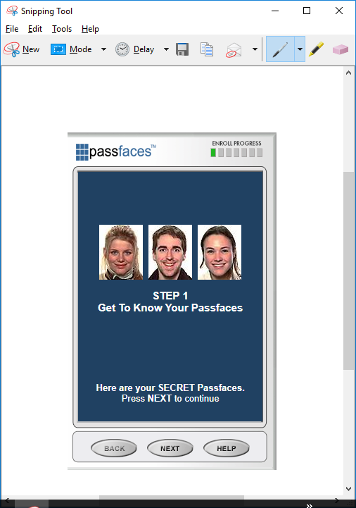

Fig.1. Step 1: Get to Know Your Passfaces

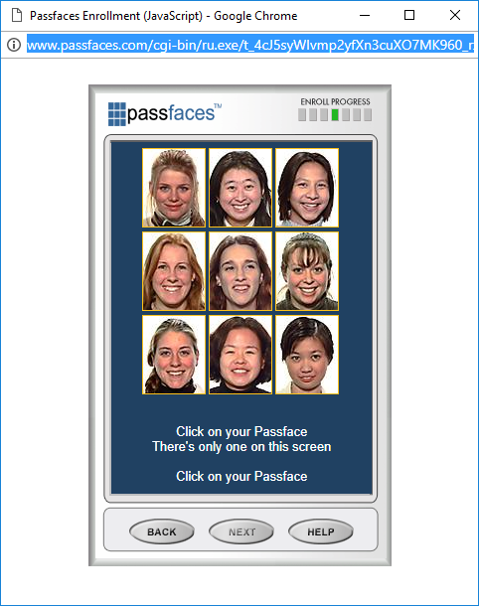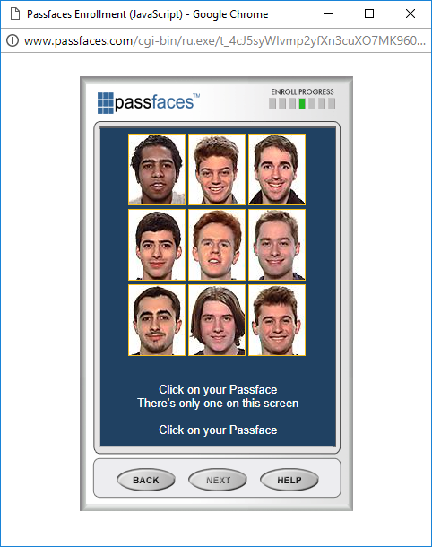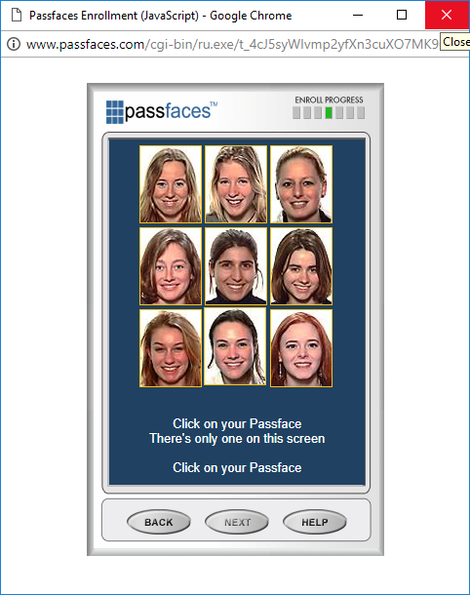

Fig.2. Step 2: Practice Using Passfaces. Select the faces given to you in Step 1 from three separate screens

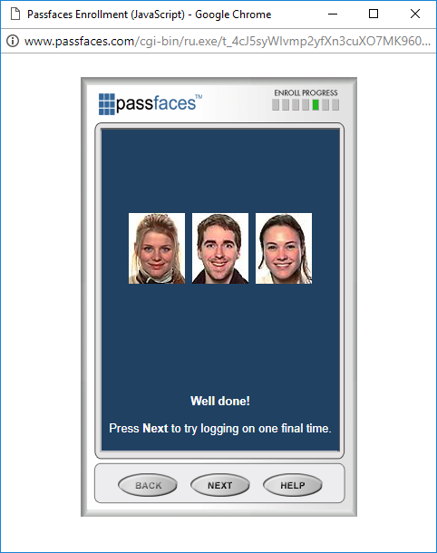 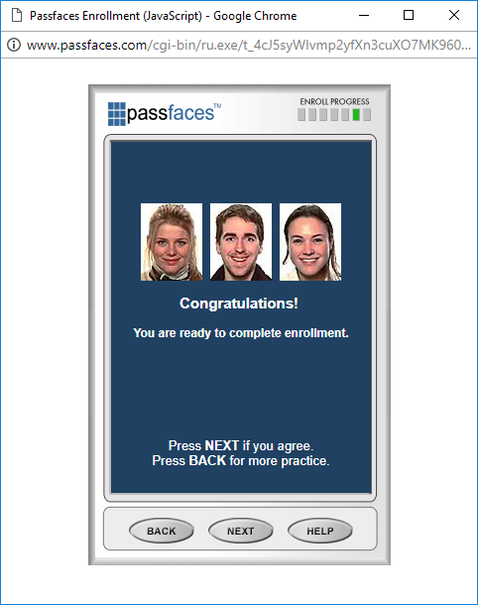

Fig. 3. Step 3: Try Logging On with Passfaces. After completing this step, you are ready to complete enrollment